Government Engineering College, Thrissur
CS333– Application Software Development Lab
Documentation -
Exp 3 – Relations on Table

Date of Submission
16 September 2020

Submitted By
Kowsik Nandagopan D
Roll No 31
TCR18CS031
GECT CSE S5

Experiment 3

AIM
Create relationship between the database

Description
Relations between the database is already created in the Experiment 1 and 2. In this experiment we will be focusing on querying from the tables that were created in the previous experiments. There are different relations between the table as explained by the ER Diagram.
Some of the questions / Queries that can be taken the database are shown as follows :-
- Select name of project manager from the database
- Select Customer Name from the database corresponding to the project name
- Select Name of technologies used in project. Display only the name of the project and name of technology
- Select the name of the project, name of consultant and effort they spent on the project
- Display the names of consultant, email, phone number
- Select the name of consultants, name of designation ad the grade
- Select the name of customer, and alternate contact phone number from the project

Output / Screenshots
1. Select name of project manager from the database
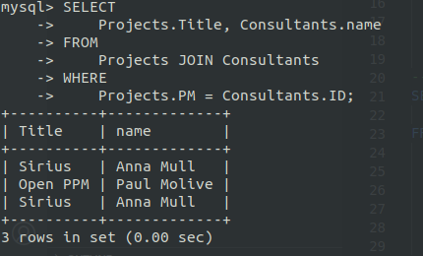

2. Select Customer Name from the database corresponding to the project name
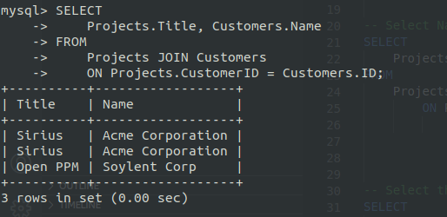
3. Select Name of technologies used in project. Display only the name of the project and name of technology
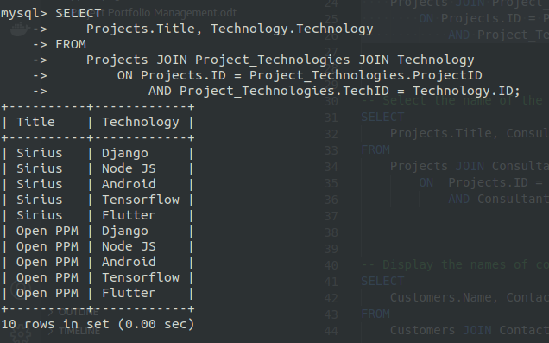

4. Select the name of the project, name of consultant and effort they spent on the project
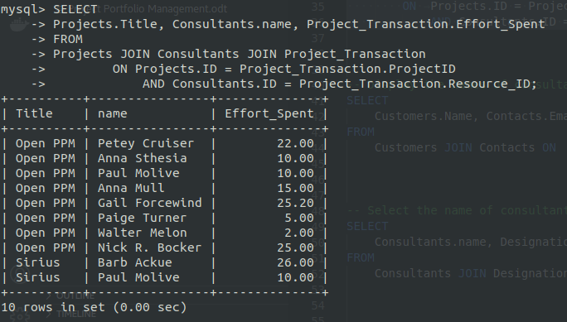
5. Display the names of consultant, email, phone number
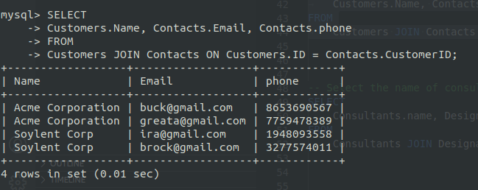

6. Select the name of consultants, name of designation ad the grade
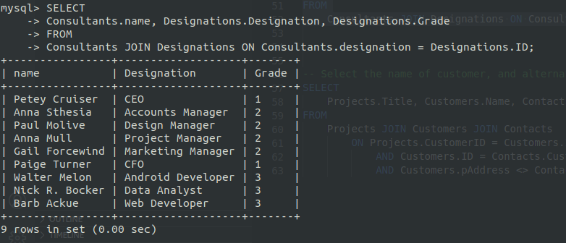
7. Select the name of customer, and alternate contact phone number from the project
